*Livevideo.com* is a really great model that id like to base the system on. It is clean and well organised. *Veoh.com* is another great example.. I am looking for layout more than colours from the beginning. Don’t worry at all about creating a design that is similar, the evolution of the system will gradually make it different.

It would really help development if tables were used instead of divs and CSS. Css is good but only for styling as opposed to positioning (which should be relative and not absolute).

I am only looking for 1 single page to work from, this will be the home page. The rest of the site can develop from here. Ill get a more detailed design to you once I have the initial home page.

There are a number of components that I need for the template:

* Header
* Front page feature
* Tabbed top rated and most viewed

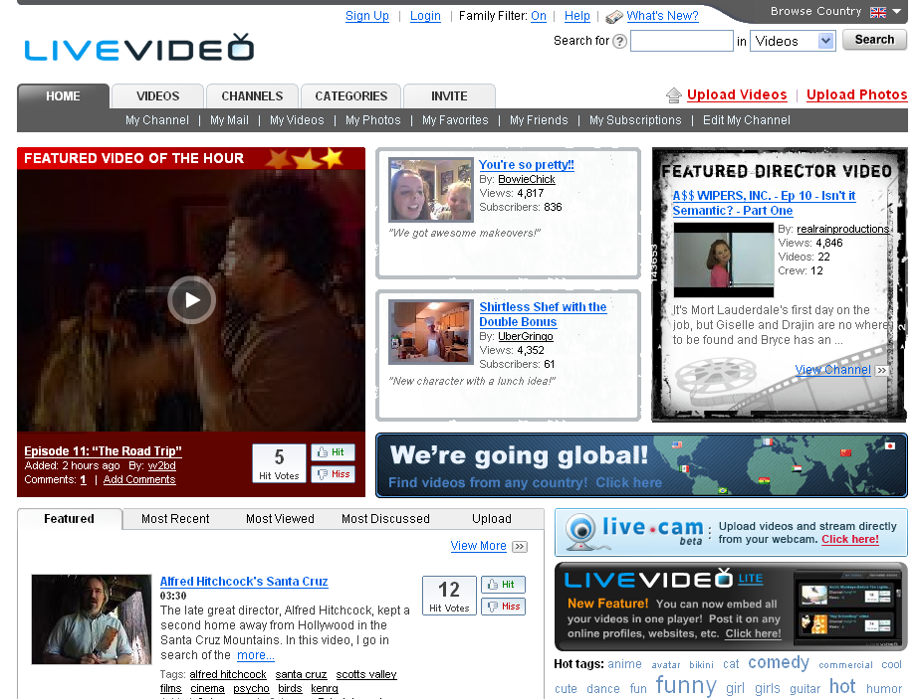

Header

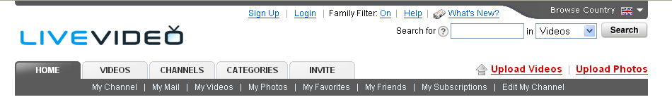

The header of the web site will reside on every page in the system and as above, must contain:

* Space for logo
* Login option/user logged in
* Family filter
* Search options
* Tabs

The top level tabs should be created at image files and contain the following:

* Home
* Friends
* Videos
* Photos
* Hotspots

All the sub level categories will be seperated with a Pipe (as above) and can be entered as xxx for development

**Feature box**

It would be good to great 2 different designs for features as they can represent different areas

The following page has a good example of a feature box. It also displays a well formed layout of videos and photos:

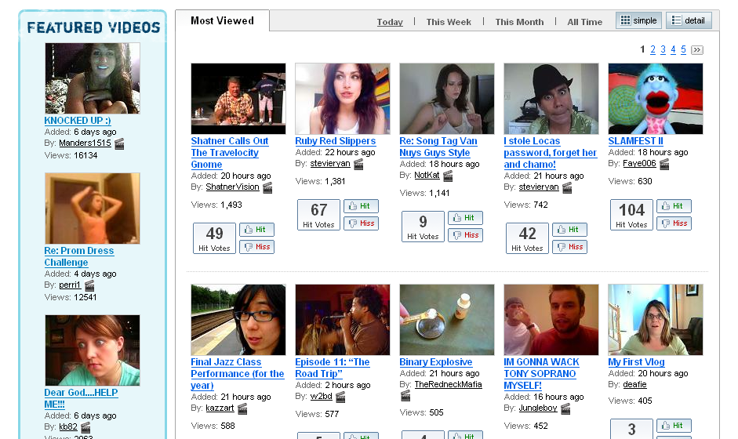

The blue box will appear as a mini feature on the home page as well as serving as the main view when browsing photos, videos and friends.

A footer for the template is also required. One similar to below is great.. don’t worry about what text and hyper links it contains as I will add these.



If you could get the layout done initially and style everything using CSS then I can get to work ASAP. Don’t worry too much about getting the colours right initially. I’m not looking for beauty from stage 1 but rather a template to work from. You can then send me updated style sheet files and ill just drop them in whenever I receive them.